Deliverables:
- Mission statement for your app (i.e., a clear description of what your app seeks to achieve and why)
The mission of this app is to provide an enhanced site experience for the First Nations monuments in Oak Bay, BC that highlights the continued role of First Nations in the landscape. The goal of the Oak Bay monuments initiative is outlined by founder Marion Cumming: to start a conversation about the people and places that lived on the land for thousands of years. When walking around the manicured streets of Oak Bay it is hard to imagine the garry oak, red cedar, and Douglas fir ecosystems that supported thousands of L’kwungen speaking peoples. This app in key to addressing the increasingly the dynamic relationship between memory and place that is being challenged in the search modern individual and group identities.

2. Statement of the characteristics of the app that make it appealing, interesting and useful (i.e., how does it help the end user)

The app maps eleven locations in Oak Bay, each with a corresponding picture and description of the historical context of the site. The app also includes a map of monument locations that is scalable, colour coded by commemoration feature type (i.e. monuments and other). This app allows for people to go beyond the physical commemoration of monuments with additional information outlining the historical and current connection of First Nations with these sites. The app will appeal to people who have visited the sites many times and people who are new to Victoria.

3. A video with voice over that promotes and demonstrates use of your app

https://youtu.be/uujVeKcMD-w

4. A well-structured readme file (in markdown format) suitable for GitHub that states the goals of your app and how to use it

In App challenge folder

5. Organized code base suitable for upload to a GitHub code repository with all applicable instructions for downloading, compiling, and/or installation.

In App challenge folder and at URL: https://arcg.is/jr1bb

6. Pick a name for your team, take a photo of all your team members (one photo of the team together if possible), and write a short bio for each member.

Team GISavvy, UVic

Trilby Buck is a fourth year geomatics student at the University of Victoria. Through experiences from an international co-op to Ghana, she realized the role of geospatial technologies for addressing local and global scale issues. Her undergraduate work has centered around using GIS and remote sensing to support community engagement surrounding environmental and social change.

Thea Mai is also fourth year geomatics student at the University of Victoria. Over the last four years she has explored GIS and remote sensing, focusing in on Vancouver crime, air pollution, and oceanography. Recently she has been examining indigenous ways of knowing and how to incorporate them into geomatics through alternative ways of mapping and connections with the land.

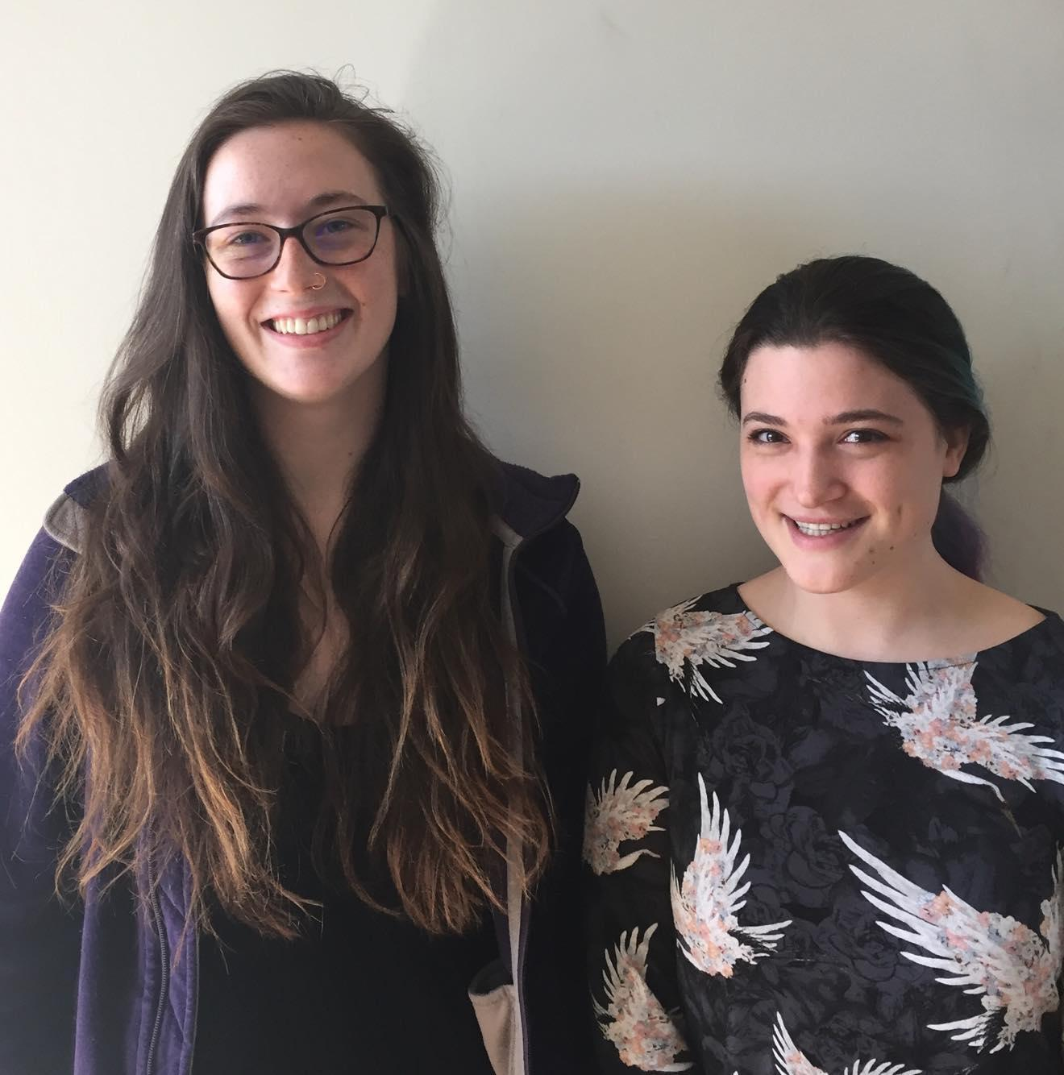
Trilby Buck (left) Thea Mai (right) together, team GISaavy

