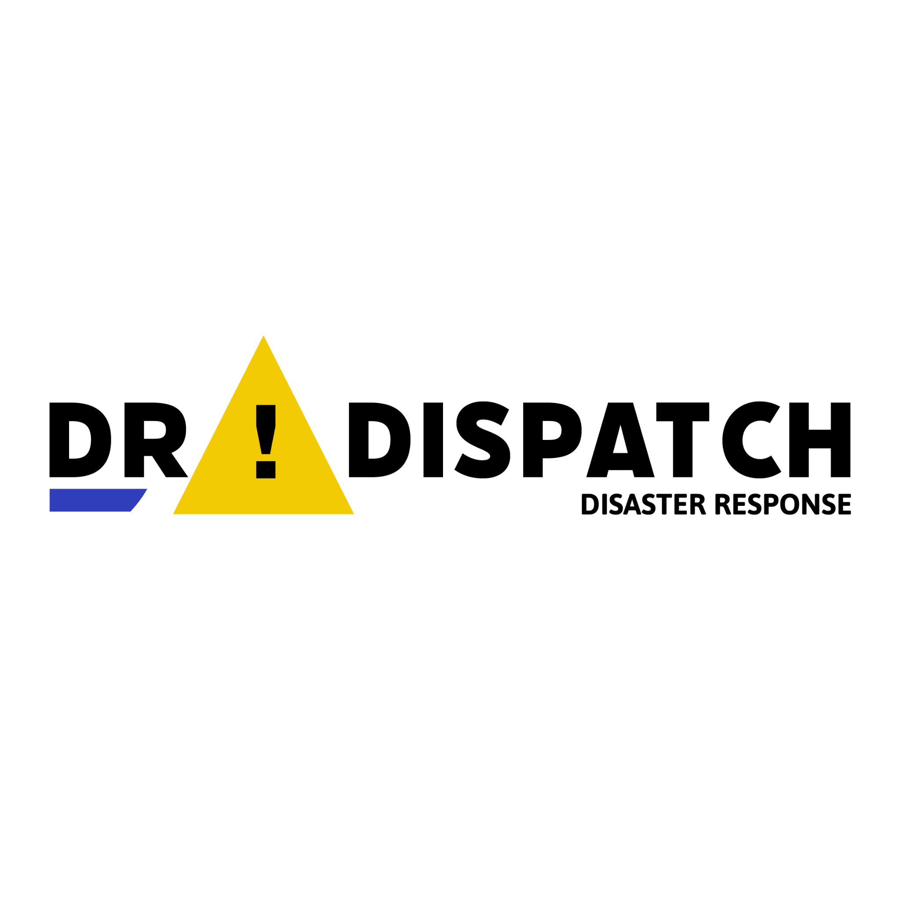
D.R. Dispatch Web Application
D.R. Dispatch is a Web Application built using ESRI's App Builder that was created for government officials to inform citizens of emergencies and disasters.

Accessing the application
The application is currently hosted on BCIT’s ArcGIS Online portal, but is shared to everyone. It can be accessed at the following URL:
https://www.arcgis.com/apps/webappviewer/index.html?id=38c1cc97bd914ce4990b41aa8cfbaa99

Map layout
- The map on the right shows all emergency areas and points, which are visible to DR Aware mobile app users in ‘Alert View’.
- It also shows several layers of threat data, including: Flood Risk, Fire Threat, Freight Rail Lines, and Coastal Industrial Areas. Note that data is currently limited in extent to the lower mainland. These layers are visible to DR Aware mobile app users in ‘Information View’.
- To swipe between views and get a better picture of what the mobile app user sees in Alert View, use the swipe layer control in the top left of the map.
- Additional features found in the top left include:
  - Swipe
  - Legend
  - Find Points (described later in this guide)
  - Zoom Controls
  - Home Button, to return to the Lower Mainland default extent, and
  - Search Bar. Use the search to find a specific place. This can be useful to quickly find a location to add an emergency.
- Top right include
  - Share
  - Layer list
  - About - with instructions
- In addition to the swipe control, all layers can be turned on or off using the layer list in the top right.

Add an emergency area
- Find the area on the map where your emergency is located
- To the left of the map, under ‘Emergency Areas’, click a template, for example, Flood.
- Move your cursor back to the map and click to start drawing the boundary of the emergency area. Keep clicking to draw a perimeter around your emergency area. Double click to finish.
- Fill in the form on the left and describe your emergency:
  - Emergency ID: Must be unique - click ‘Get Unique Emergency ID’ to obtain an ID on a new webpage and then copy/paste it into the Emergency ID field.
  - Name: provide a short, descriptive name
  - Description: add additional details about your emergency for citizens to view on the mobile app
  - Type will be defaulted to the template you chose on creation, but can be changed
  - Closed: 0 means no, or OPEN. This the default.
  - Edit Geometry: click this to modify your emergency area perimeter
  - Click Save
  - The emergency area is now created! DR Aware mobile users will receive a notification on their phone when they enter within 1km of the emergency area. They will also be able to see the area perimeter and an alert with the detailed description within the app.

Add an emergency point of interest
Emergency points must be directly related to an emergency area using the Emergency ID. These could be points of interest like temporary shelters, information centres, supply depots, meeting areas or muster points.

- Find the area on the map where you want to place the emergency point (the search is helpful for this)
- To the left of the map, under ‘Emergency Points’ click a template. Most of the time, you will want to create an ‘Open’ point of interest.
- Move your cursor back to the map and click to add the point
- Fill in the form on the left to describe your point:
  - Emergency ID: Must be the same as the Emergency ID of the related emergency area
  - Name: provide a short, descriptive name
  - Description: add additional details about your point for citizens to view on the mobile app
  - Closed: 0 means no, or OPEN. This is the default.
  - The emergency point is now created! DR Aware mobile users will be able to see the point on the map and will receive an in-app alert with the detailed description when they enter within 1km of the point

Find emergency points related to an emergency area
- Click the Find Points icon in the top left of the map
- Enter the Emergency ID you want to find points for
- Click Apply
- The map will zoom to the first point found
- On the Results tab
  - Click the button to view a list of all points found. Click a point on the list to go to that location
  - Click the button and then ‘Show All Related Records’ to view the related emergency area

View a related emergency area for a point
- Click the point you want to view the related area for
- Scroll to the bottom of the popup
- Click Emergency Areas
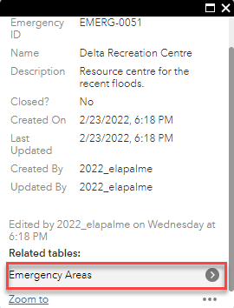
- The related emergency area will be shown on the map

Update an emergency area or point
Simply click on the area or point you want to update, update fields, and then click save. For example, you may want to update the description of an emergency area to reflect a changing situation.

To protect data integrity, note that you cannot update the Emergency ID of an area. But you can update the Emergency ID of a point to associate it to a new area.

Close an emergency area or point
Closing an emergency area or point is done via an update. Click on the area or point you want to close, change the 0 to 1 and click save. Closed points are symbolised differently on the map.

Closing a point is useful when you want to let citizens, who may have been previously accessing resources at the location, know that it is no longer available.

Delete an emergency area or point
Important: this action cannot be undone!

You can delete areas and points that are no longer required (for example, they have been closed for a period of time) or that were created in error.

Click on the point or area that you want to delete and then click the delete button on the left panel.

Important: if you delete an emergency area, all points associated with that emergency ID will also be deleted! Points can be deleted independently, though.

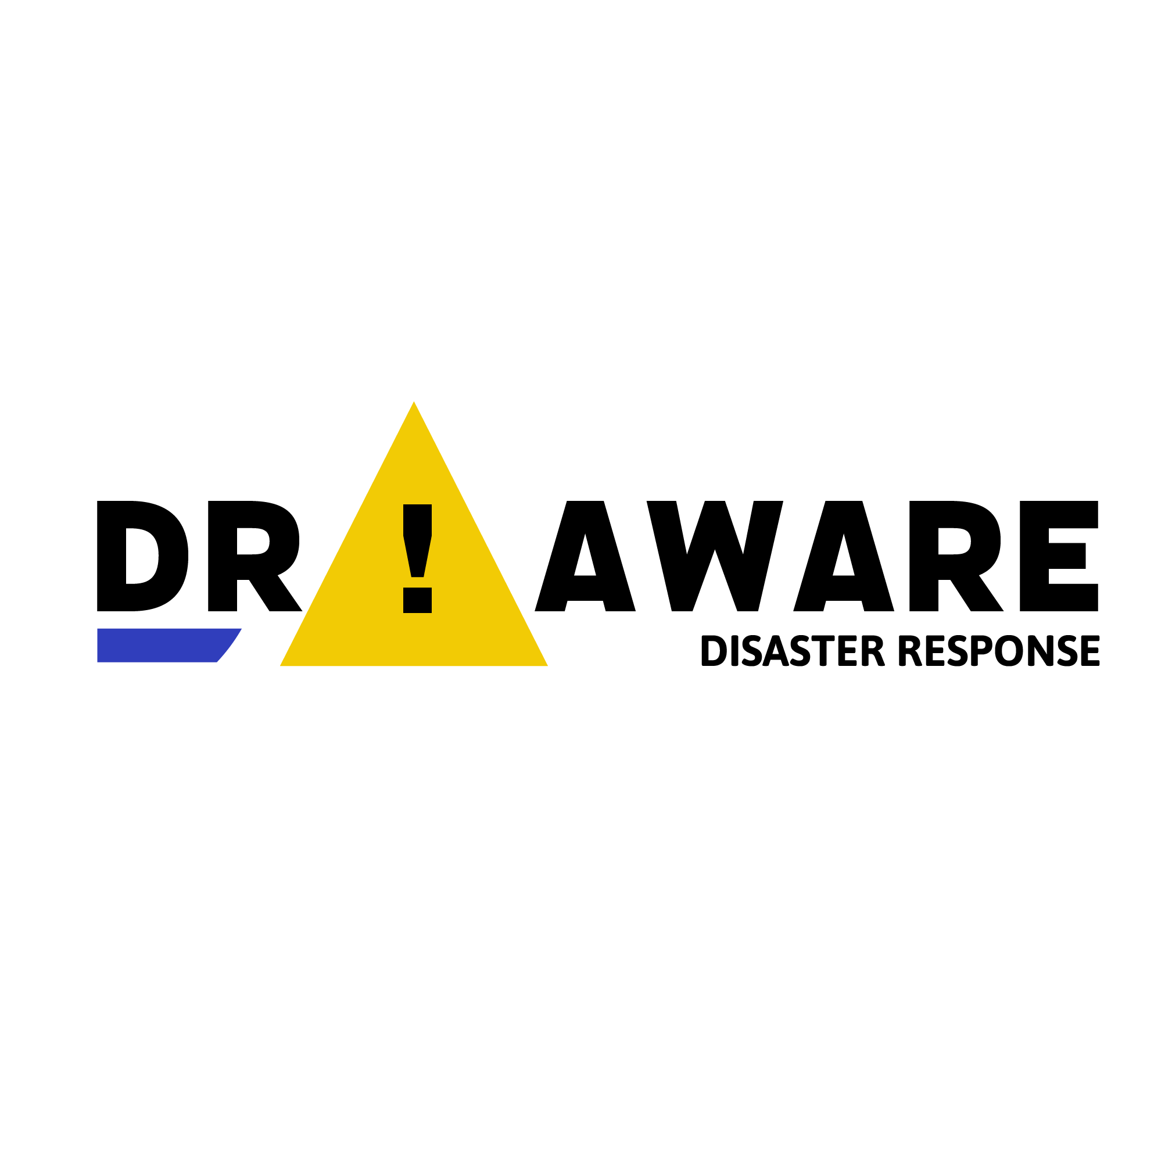
D.R. Aware Mobile Application

D.R. Aware is a native mobile application for your iPhone (iOS 13.0 and up) or Android (6.0 and up) smartphone that alerts you to emergencies in your area and also lets you view potential threats.

Accessing the application
For the short duration of the app challenge, the app was not published as a standalone app. You must install the ESRI AppStudio Player app on your phone. You do not need to Sign In or need an ArcGIS Online account.

Once AppStudio Player is installed, use your phone’s camera to scan the application QR code. This will open the AppStudio Player app and download D.R. Aware, which is launched from within the AppStudio Player app. The first time you launch the app, make sure to always allow it to access your location, or you will not receive notifications when you are close to an emergency!

App Modes and notifications
When the D.R. Aware app loads, you must choose a mode to use:

Touch Mode
This mode was designed for testing and demo purposes for the ESRI app challenge. It lets you tap to move your position to a new point. This allows you to test out alerts and notifications without having to physically move (every programmer’s worst nightmare). Note that you will receive notifications, but the app must be running in the foreground.

GPS Mode
This mode must be used to receive phone notifications when the app is running in the background. In this mode, your phone provides your approximate location to the app. Note that, for the scope of this App Challenge, the app must be running in the foreground or background in GPS Mode with your location shared to receive notifications.

You will receive a banner notification on your smartphone when you are within 1km of an emergency area. Tapping the notification will open the D.R. Aware app, where you can view further details of the area.

Press and hold the mode you want to use.

Alert View
After choosing a mode, you will be in ‘Alert View’, by default. In this view, you can view your position and surroundings on the map.
- Any emergency areas and points will be shown on the map.
- Pinch to zoom in and out.
- Tap the legend and scroll to view the meaning of map symbols.
- Press and hold on an emergency area or point to view details in a popup.

If you enter within 1km of an emergency area, you will receive an alert (in addition to a phone notification) in the red area at the top of the view. Tap ‘See More’ to see more details.

If you enter within 1km of one or more points of interest related to an emergency area, you will receive an alert in grey describing the points. Again, tap ‘See More’ to see more details.

Information View
To change tabs, tap ‘Information View’ at the bottom of the app.

Information view provides a map with potential threats, including flood risk, fire threats, freight rail lines, and industrial area, that you can browse and use for your personal emergency planning. You can press and hold on an industrial area or rail line to view additional details in a popup. The legend functions the same as Alert View.

